I spy with my little eye…….2 things you can eat…..a tiny little family…….and something a bird has left…..

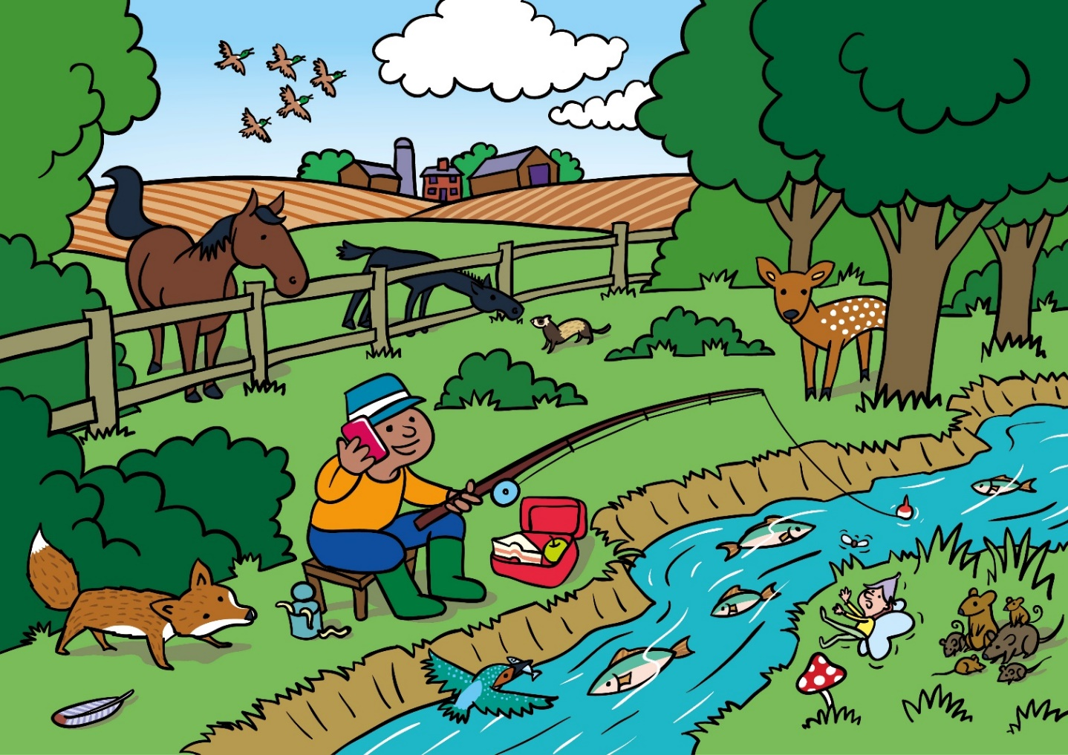

Can you name…the game the gorilla is playing? The animal peeping through the gate? The musical instrument?

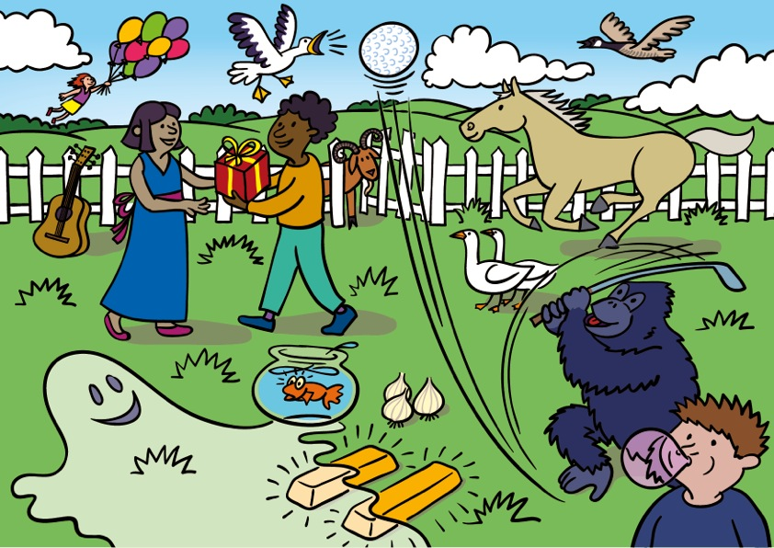

Can you make up a story about the pirate in the picture…what does she like to play with? What does she like to eat? What might she be going to do with her pumpkin? Do you know the celebration that has pumpkins out each year?
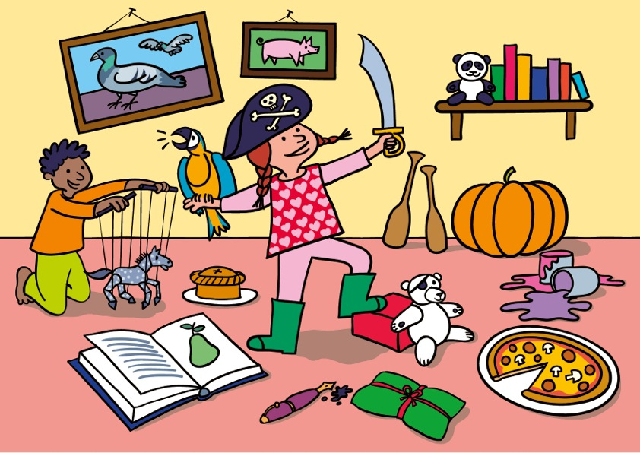

Find 10 things starting with ‘s’…..
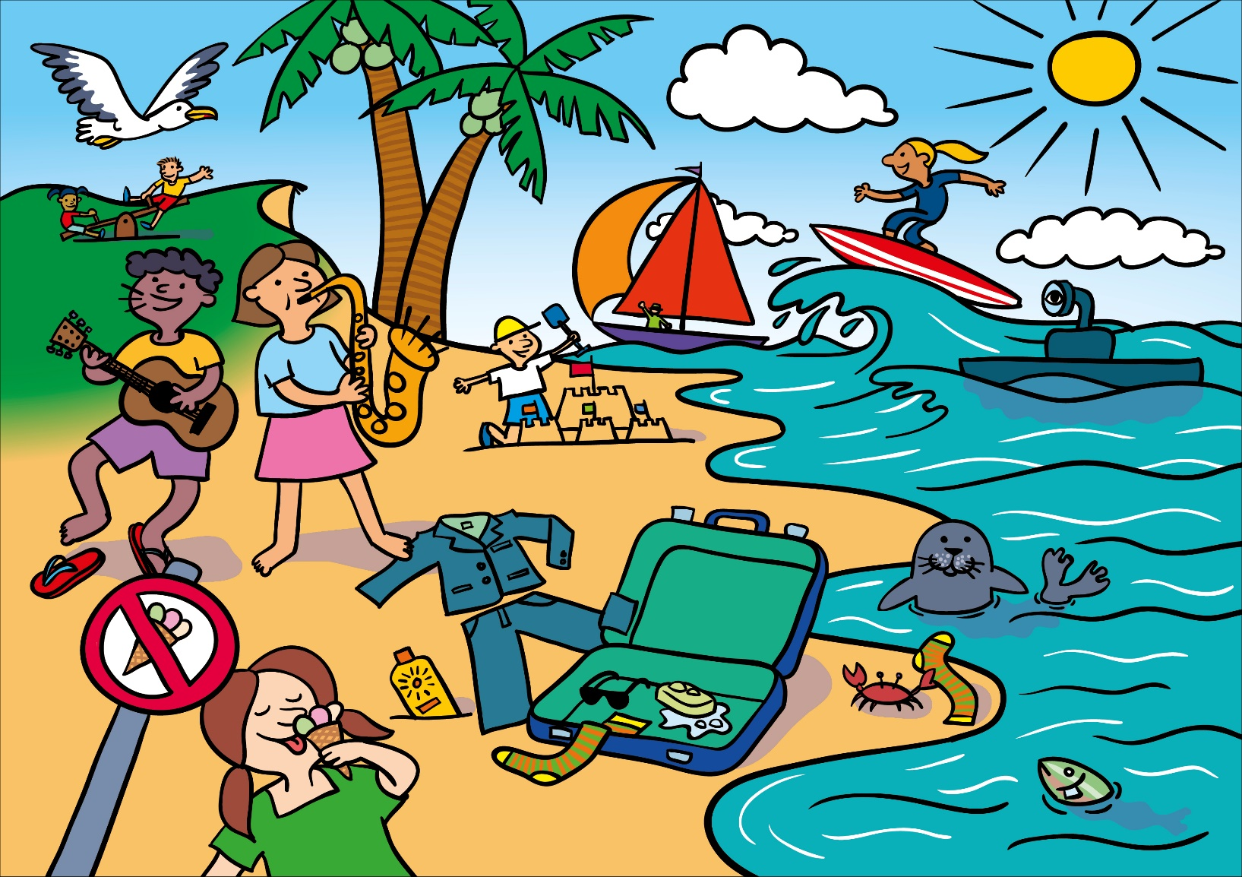
Syllables…..clap out the name of things on the picture to count the syllables e.g. ‘te…nis’ (2 syllables)…then can you find a drink name with 1 syllable ….a flower name with 2 syllables….an animal name with 3 syllables and then can you think of any of your own words/names that have 4 syllables (there aren’t any on the picture
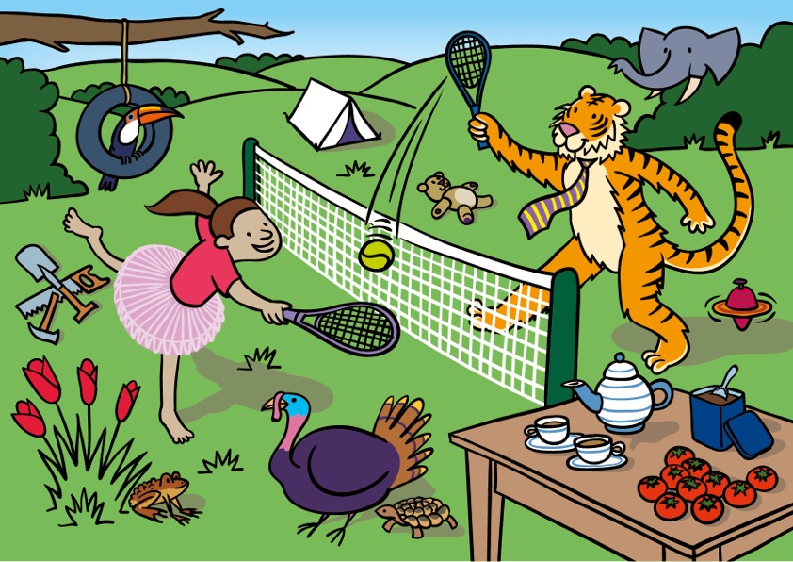

10 things that start with the k c sound

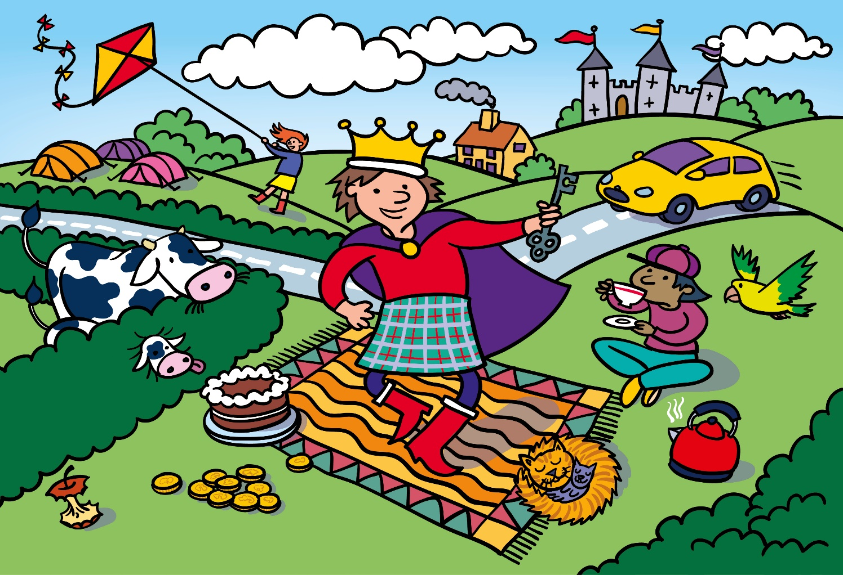
How many action words (verbs) can you find e.g. ‘the wind is ?’, ‘the hand is ? the corn’

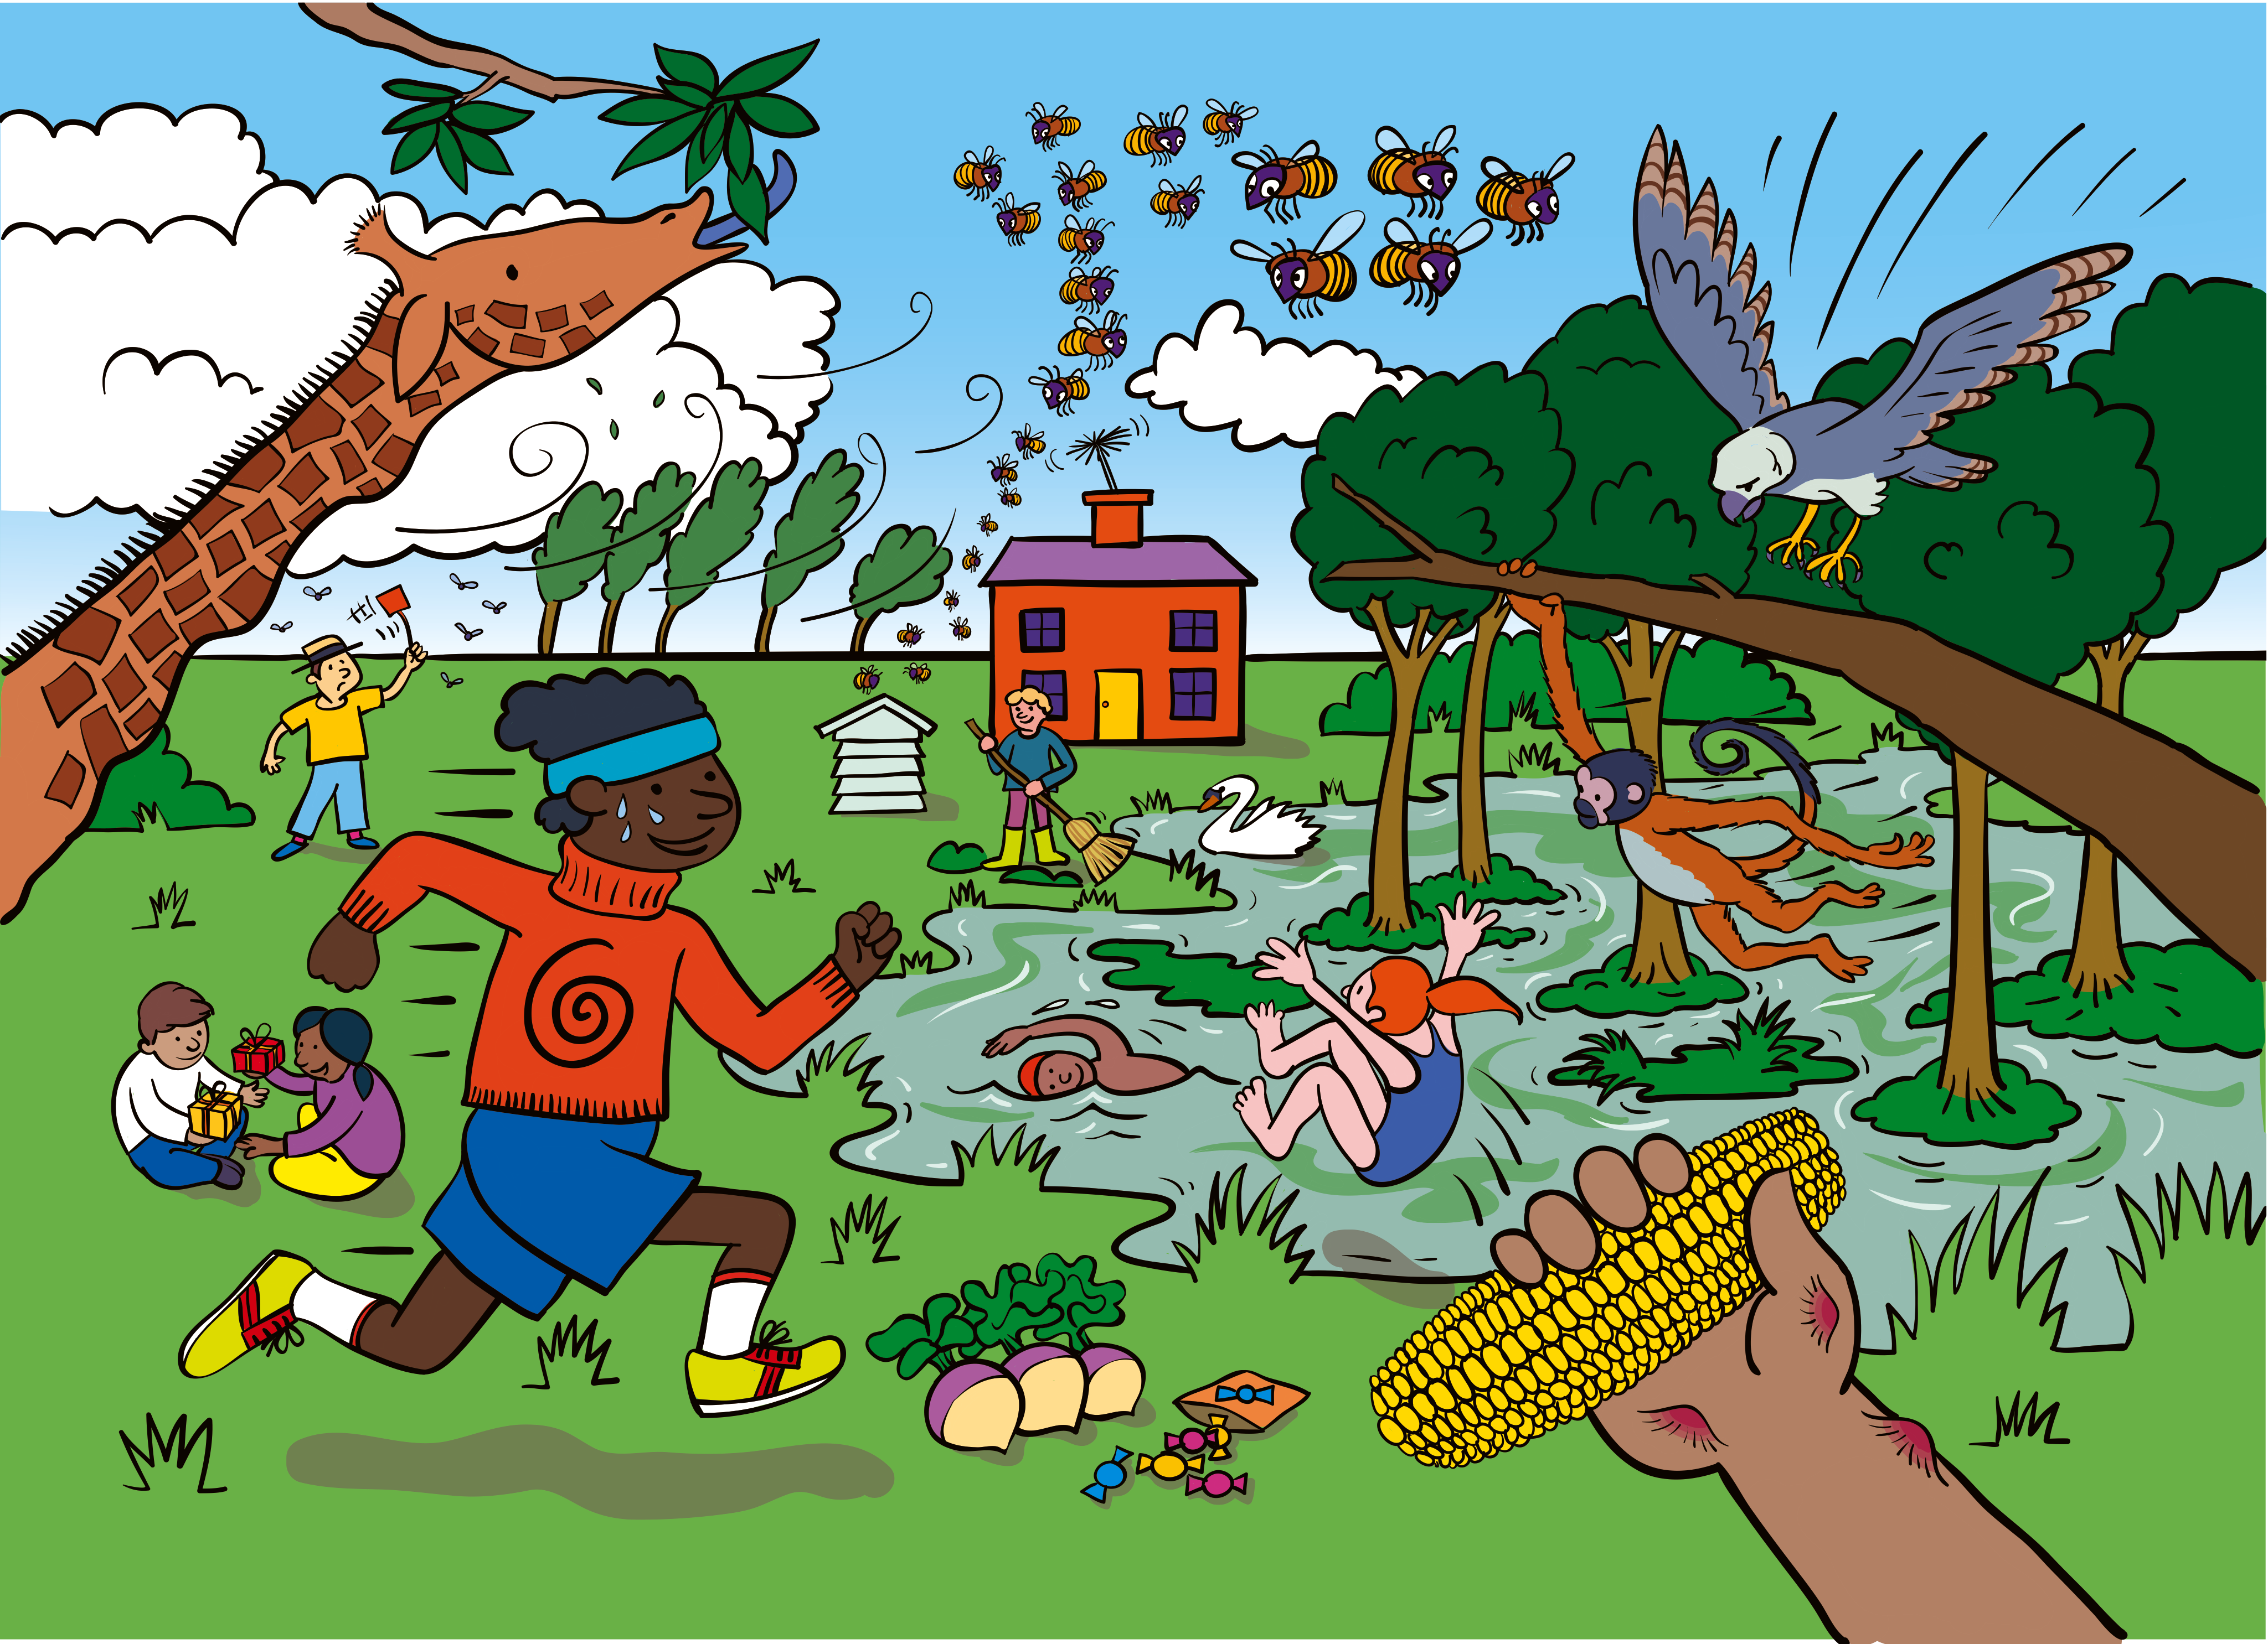

6 people, 2 things with wheels, a tool and 2 things that meow….

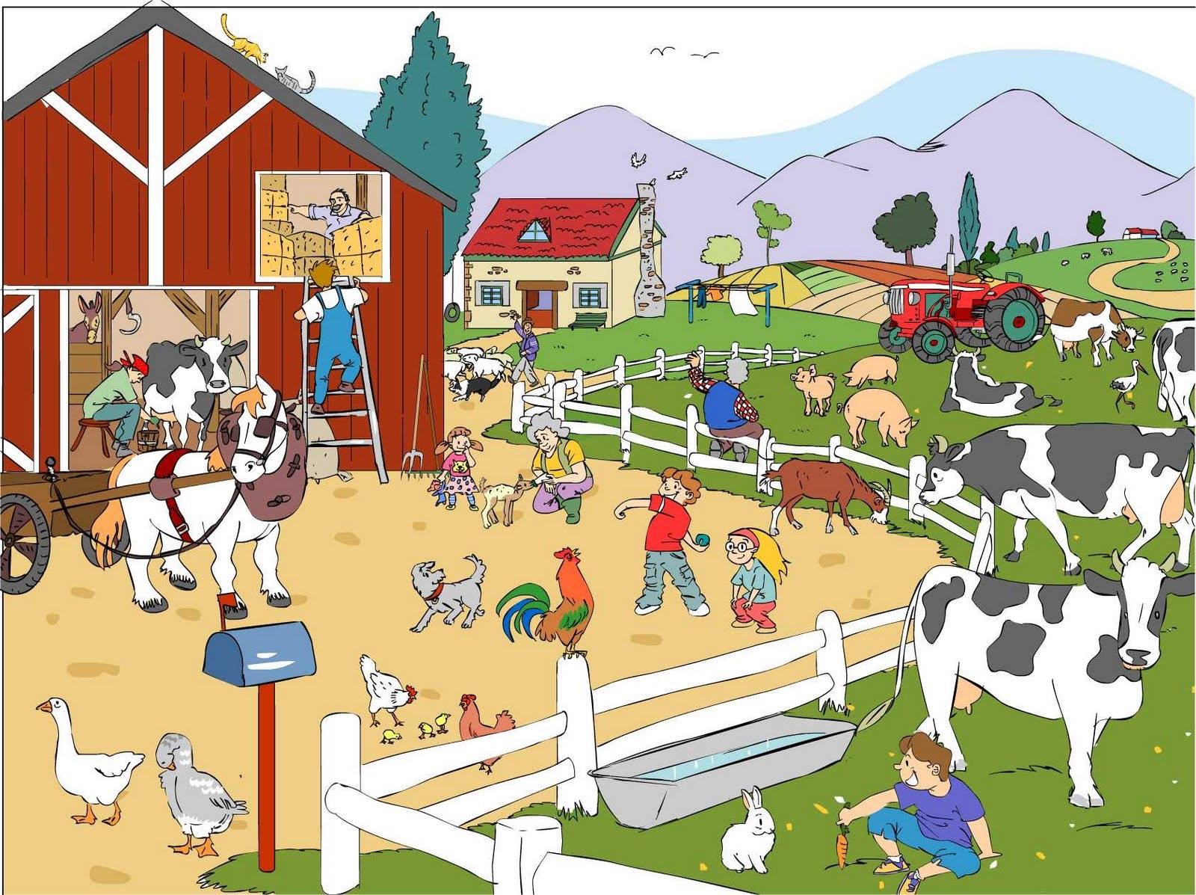

6 different types of sea creatures on this picture….

