Farms

Some people live in busy towns where there are no farms, other people live in smaller villages in the countryside where farms are often found. Have you got a farm near your house? If not maybe you have visited one or seen a TV programme about a farm?
Can you name 5 things you find on a farm…or if you are over 7 years old name 10! Can anyone in your family think of anymore?

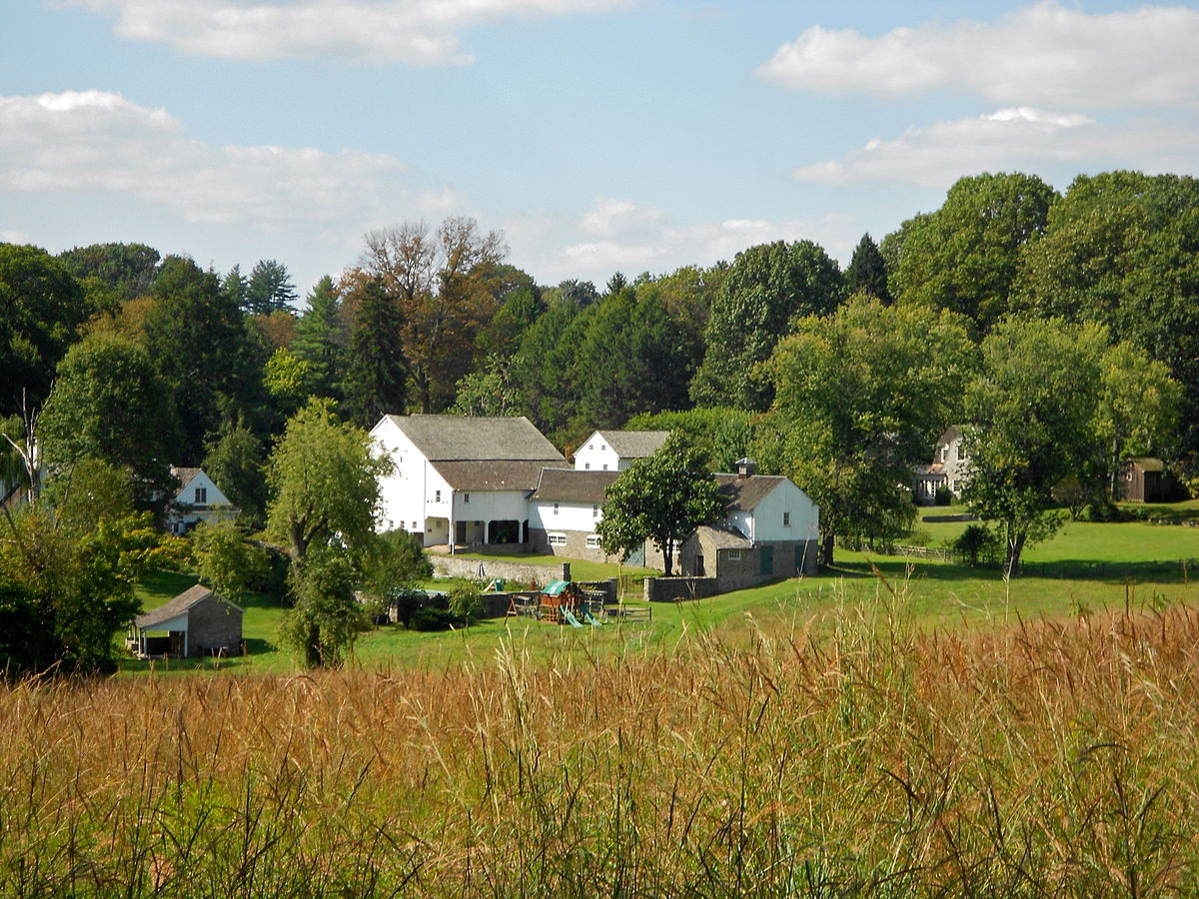
This Photo by Unknown Author is licensed under CC BY-SA

Nature
Look at the bird below… how many legs has it got? Can you think of some more animals with the same number of legs?

Can you find it’s beak? How many more animals can you think of that have beaks? Do you think they have teeth inside their beaks? If you are not sure, can you or your parent/carer google it to find out?

What do we call the covering on a bird’s body? Is it skin……fur…….or feathers?

Can you think of the names of 5 different birds? What other creatures live in your neighbourhood?

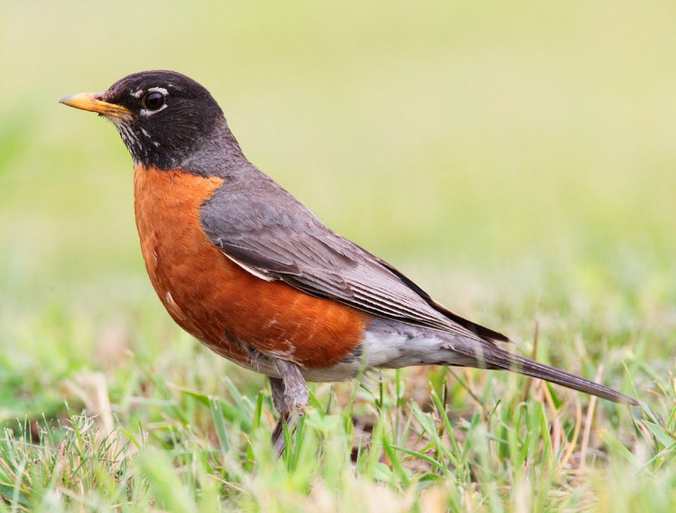
This Photo by Unknown Author is licensed under CC BY-SA
Story time

Lots of people enjoy looking at books……Do you know where you can go in your community to borrow books from?

What is your favourite book? Who is it about? Where do the characters go? What do the characters do? Why do you like it?

Can you remember the story and tell it to someone in your family?

People that help us.

What is this man’s job? How does he help us?

Can you guess the names of who I am talking about now?
Someone who helps us cross the road…
Someone who checks our teeth for us?
Someone who puts out fires?
Someone who rescues us if we need help in the sea/swimming pool?
Someone who teaches us?
Someone who catches people who break the law?

This Photo by Unknown Author is licensed under CC BY-NC

Let’s count

Can you count how many different coloured doors there are in your street or on your next walk?……….what is everybody in your families favourite colour?

Can you think of something else you can count in your street or on your walk? Lampposts? Street lights? Telegraph poles? For sale signs? Do you know what all these things are for?

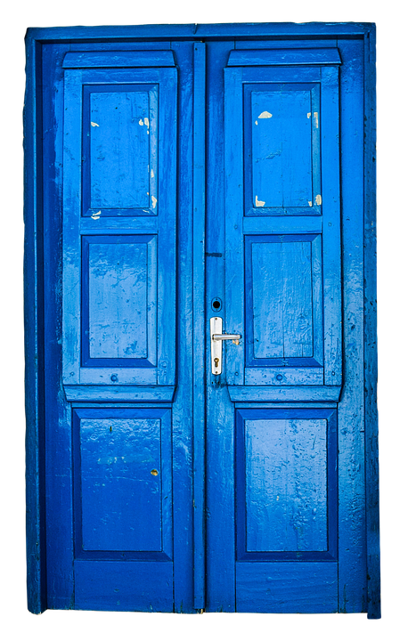

Growing things
In some areas that people live there are special places that people use to grow things. It is called an allotment. Are there any allotments near where you live? Other people grow things in their gardens or in pots by their doors or on windowsills in their houses.

What kinds of things can you grow on an allotment or in your garden/house? How many can you think of? Are you growing anything at the moment?
If you could grow one thing what would it be?

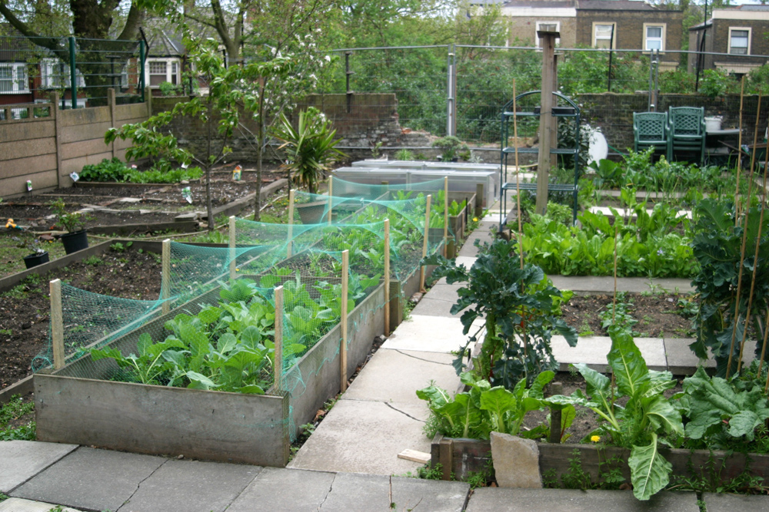
This Photo by Unknown Author is licensed under CC BY-SA-NC

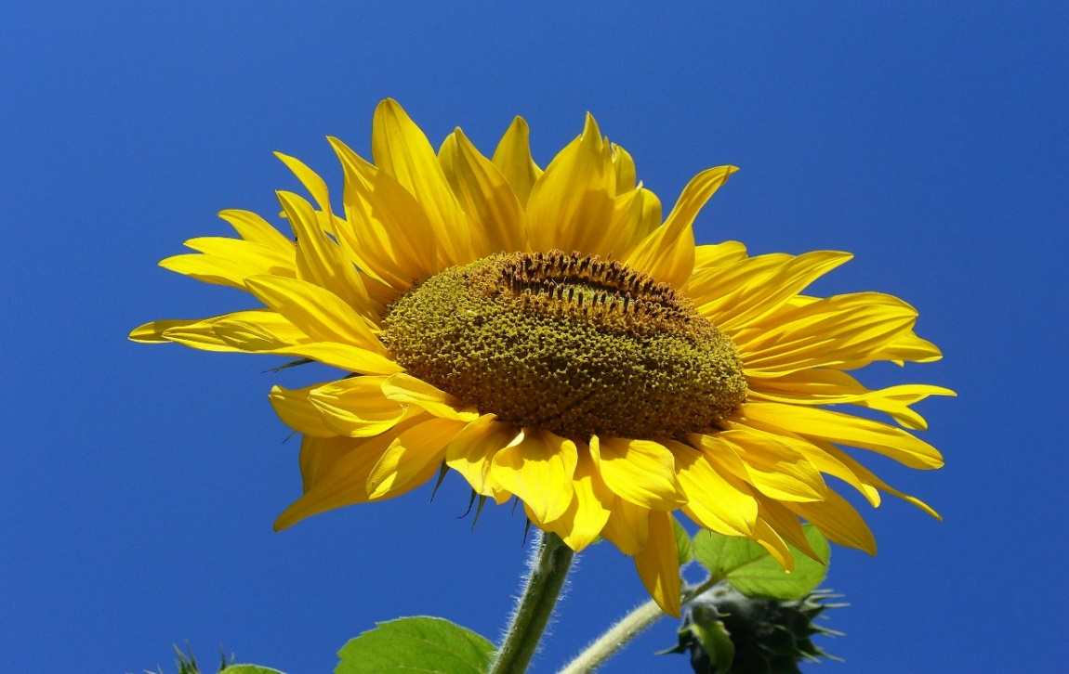
This Photo by Unknown Author is licensed under CC BY-SA

Food and drink.

There are usually lots of places in our community for us to enjoy eating Can you think of food you might eat at these different places?
In your garden?
In the park?
At teatime in your home?
In a café?
In a pub?
From the fish and chip shop?
Where is your favourite place to go to eat?

Find out from your family what everybody’s favourite food or drink is….

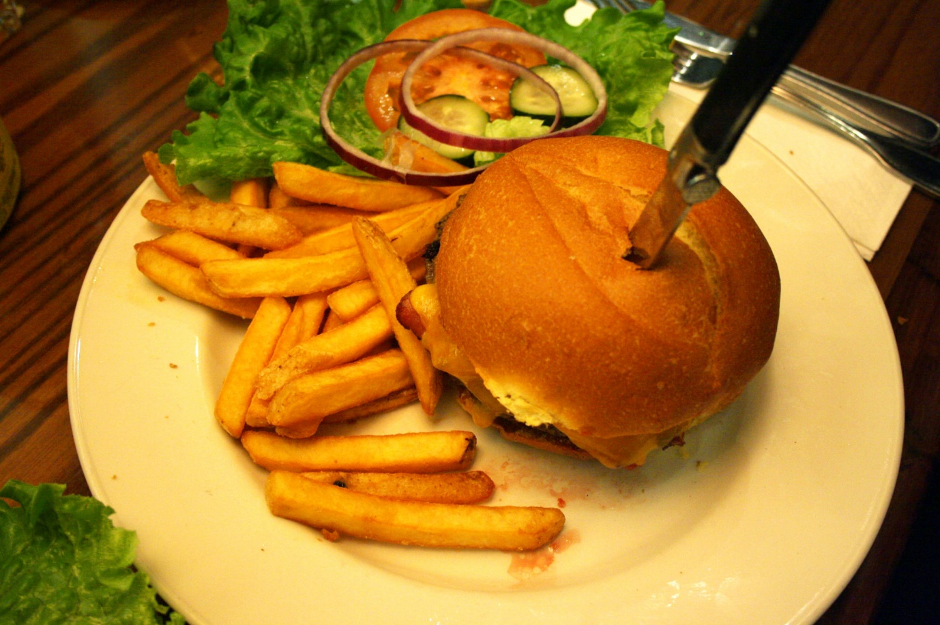
This Photo by Unknown Author is licensed under CC BY-SA

Use your senses

Try this at different times of the day…go out of your front door…..

What different things can you hear?

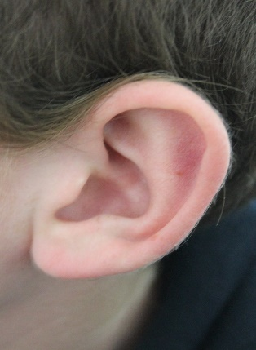
This Photo by Unknown Author is licensed under CC BY-SA

What different things can you see?

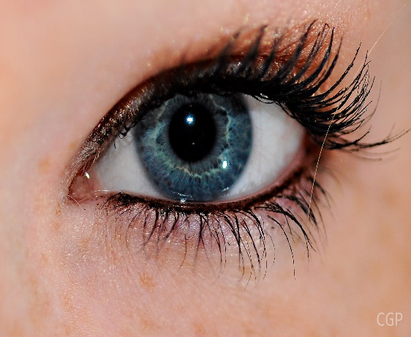
This Photo by Unknown Author is licensed under CC BY-SA

What different things can you smell?

This Photo by Unknown Author is licensed under CC BY
Water
Do you have any water in your community? How many of these types of water have you got…pond, river, lake, canal, the sea, a stream, a puddle? Any others?
We cannot live on water but lots of things do

Who or what can swim in the water?

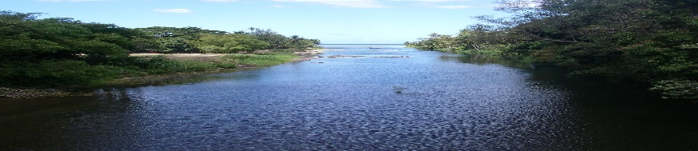
This Photo by Unknown Author is licensed under CC BY-SA

Who or what can fly across the water?
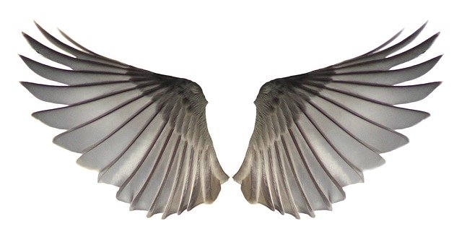
Who or what can quack near the water?
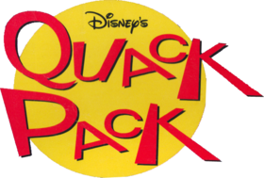
This Photo by Unknown Author is licensed under CC BY-SA
Can anything hop by the water?
This Photo by Unknown Author is licensed under CC BY-SA

Christmas
Do you have a Christmas tree that goes up in your town, village or neighbourhood?
Where does it go?
What goes on it?
Do you visit it?
What else can you remember about Christmas in your community?

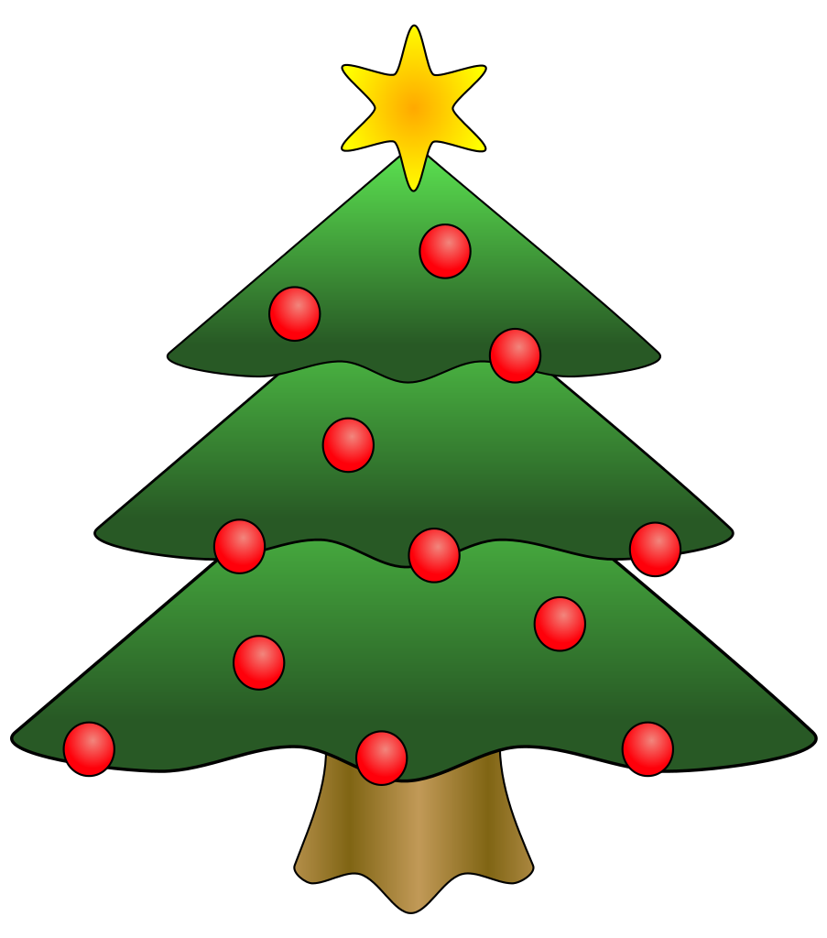
This Photo by Unknown Author is licensed under CC BY-SA

