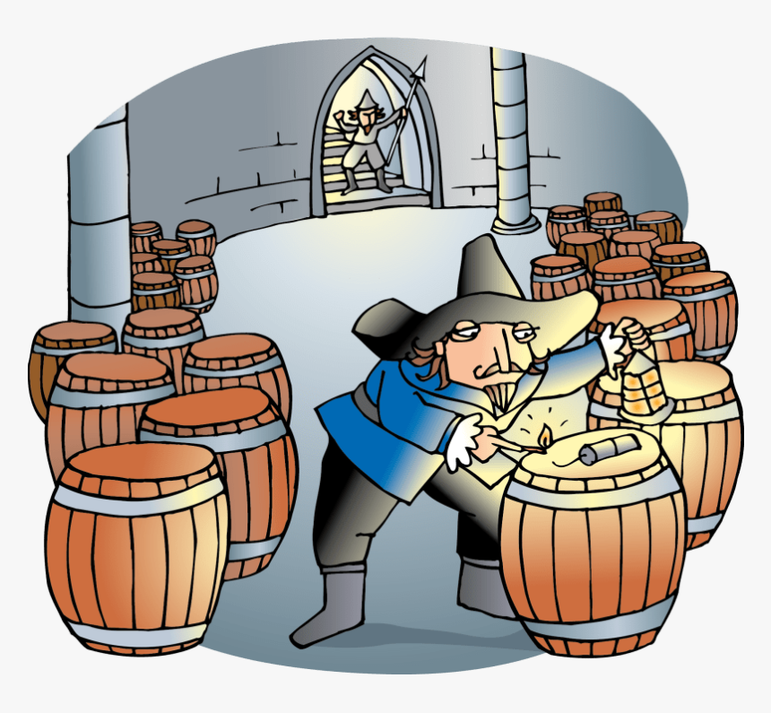
As readers and writers we will…
-Use our class text ‘Into the Forest’ to write a character description and a report surrounding the topic of the woods.
- Learn about grammatical structures and punctuation, and how these are used to improve our pieces of writing.

In RE we will...

-Explore the concept of temptation by considering the difference between right and wrong, through a number of well-known Christian and Sikh stories and teachings.

As mathematicians we will be learning…

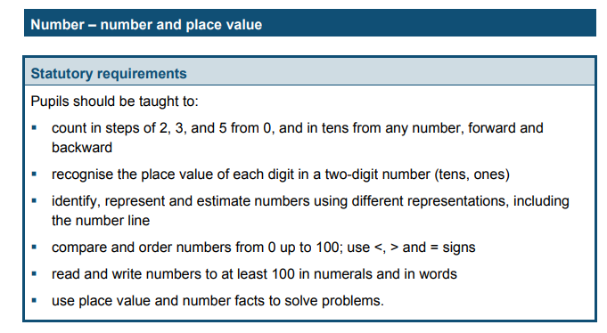

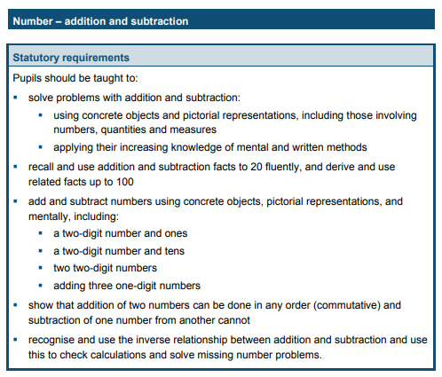
Year 2 Autumn One

As designers, we will…
-explore different vehicles and how they move.
- we will be learning about mechanisms and we are going to make our own fairytale vehicles using wheels and axels.

As scientists we will…

-Learn the relationship between animals and their habitats.
-Explore food chains and develop our knowledge of how animals survive through interdependence with plants.

As historians we will…

-Learn details of the Gunpowder Plot in 1605.
-Learn about Guy Fawkes and find out why he was a significant person in history.

As sportspeople we will…

- Improve our fitness.
- Work on our athletic skills and techniques
- Discuss the impact of exercise on our bodies.

In computing we will...
-Learn how to keep ourselves safe and protected online.

